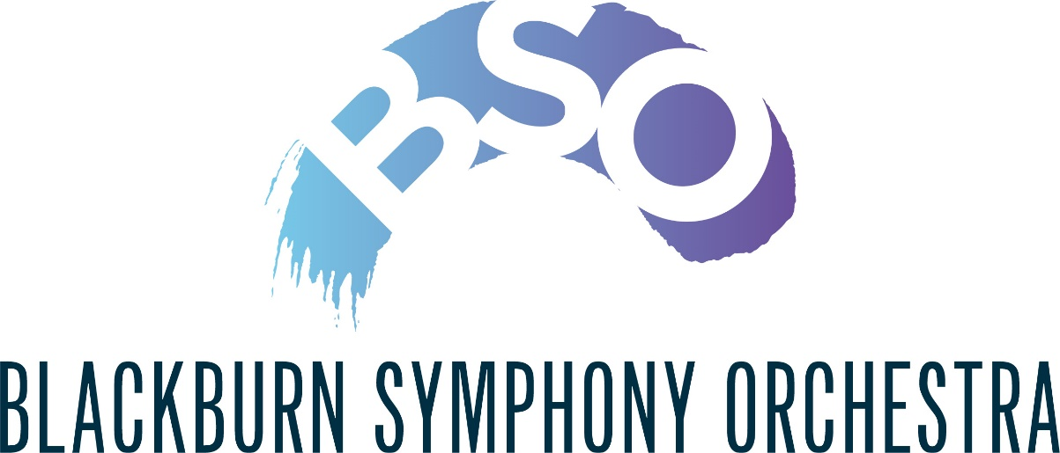

PATRONS

If you have enjoyed this concert would you like to become a Patron of the orchestra? We ask Patrons to make a minimum donation of £30.
For each £15 donated you will receive a Patron’s Ticket Voucher which enables you to buy a concert ticket at a reduction of £5.
If you are a UK taxpayer you may Gift Aid your donation.
NAME …………………………..……………..…………………………….
ADDRESS …………………………………..……………………………..
………………………………………………POSTCODE ………………..
EMAIL …………………………………………………………………..
I wish to become a Patron of Blackburn Symphony Orchestra and enclose a donation of £30 ……. other £………..
Cheques should be made payable to Blackburn Symphony Orchestra
Gift Aid
I want to Gift Aid my donation and any donations I make in the future or have made in the past 4 years to Blackburn Symphony Orchestra.
I am a UK taxpayer and understand that if I pay less Income Tax and/or Capital Gains Tax than the amount of Gift Aid claimed on all my donations in the tax year it is my responsibility to pay any difference.
Please sign below to enable Blackburn Symphony Orchestra to reclaim the tax you have paid on your donations in the past four years and any future donation that you make.
Signature .................................................................. Date ....................
Please return this form together with your cheque (if applicable) to
Margaret Popham, 34 Mellor Brow, Mellor, Blackburn BB2 7EX or bsopatron@btopenworld.com

