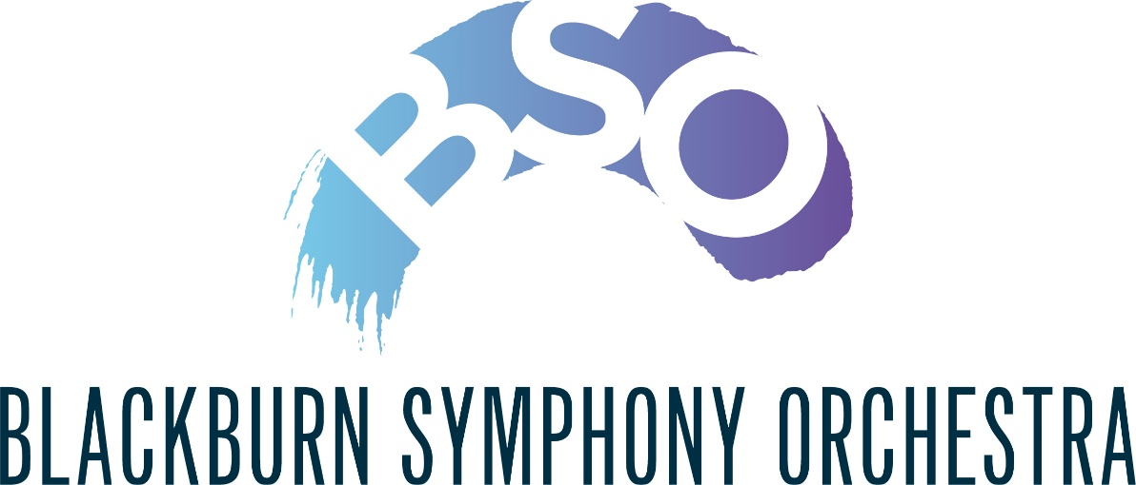

**Player Chair Sponsorship**

A Player Chair Sponsorship is a direct way for you to support the further development of the Blackburn Symphony Orchestra. Chair Sponsors sometimes choose an instrument they particularly love or a player they know. It is a very visible show of support as the donor's name appears next to the sponsored musician's name in concert programmes. This unique kind of sponsorship is an opportunity to get to know more about the Blackburn Symphony Orchestra and to have a special connection with the musicians on stage during the concerts.

We ask sponsors to make a minimum donation of £90, for which you will receive the following benefits: -

1. Three complimentary tickets to use at your discretion.
2. Priority reserved seating.
3. Interval hospitality for two.
4. Personal accreditation alongside your sponsored chair in all Blackburn Symphony Orchestra concert programmes.
5. Invitations to attend selected orchestral rehearsals throughout the season

For more information about sponsoring a musician’s chair, contact Mike Lormor ([bsopatron@btopenworld.com](mailto:bsopatron@btopenworld.com)).

To become a sponsor, please complete your details below.

If you are a UK taxpayer you may Gift Aid your donation.

NAME(s) ………………………………………..……………..…………………………….

ADDRESS ……………………………………..…………..……………………………..

…………………………………………………..…………POSTCODE ………………..

EMAIL …………………………………………………………………..

I/We wish to become a sponsor of the following chair……………………………………………

Sponsorship amount £…………………..

Cheques should be made payable **to Blackburn Symphony Orchestra**

**Gift Aid**

I want to Gift Aid my donation and any donations I make in the future or have made in the past 4 years to Blackburn Symphony Orchestra.

I am a UK taxpayer and understand that if I pay less Income Tax and/or Capital Gains Tax than the amount of Gift Aid claimed on all my donations in the tax year it is my responsibility to pay any difference.

Please sign below (one signature only) to enable Blackburn Symphony Orchestra to reclaim the tax you have paid on your donations in the past four years and any future donation that you make.

Signature ............................................................................... Date ............................

Please return this form together with your cheque (if applicable) to

Mike Lormor at 18 Yeadon Grove, Chorley, PR7 2QJ or to [bsopatron@btopenworld.com](mailto:bsopatron@btopenworld.com)